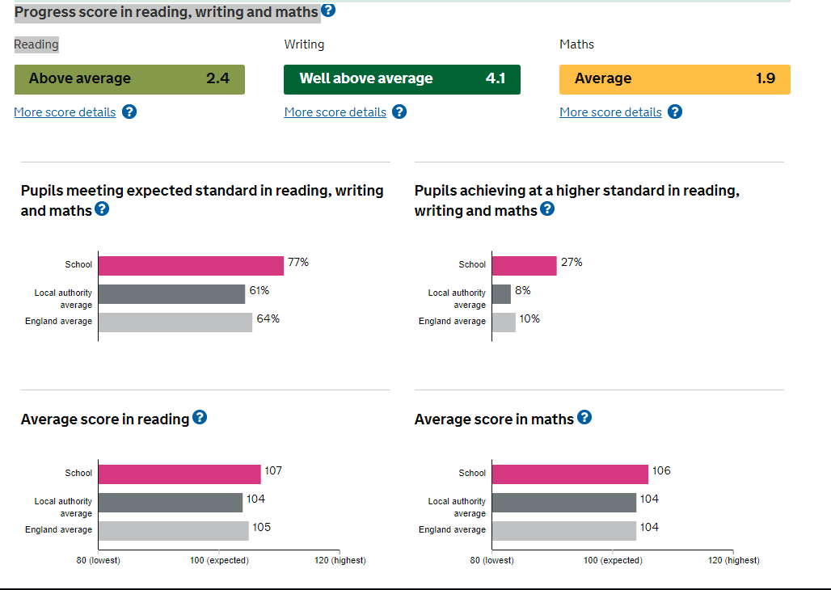

Average scaled score in reading test 2018 – 105
Average scaled score in maths test - 106
Wycliffe Performance KS2 - 2018
Percentage of pupils reaching expected standard in reading, writing and maths | 77%
Percentage of pupils reaching higher standard in reading, writing and maths | 27%
Average progress that pupils have made in reading between KS1 and KS2 | 2.4
Average progress that pupils have made in writing between KS1 and KS2 | 4.1
Average progress that pupils have made in maths between KS1 and KS2 | 1.9
Average scaled score - Reading | 105
Average scaled score - Maths | 106
Link to performance tables | https://www.compare-school-performance.service.gov.uk/school/132178/wycliffe-cofe-primary-school

