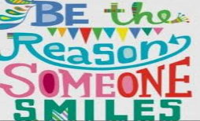  All Different – All Equal | Spruce Class  Mr Owen & the Spruce team  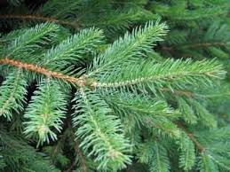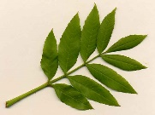 |  |  |  |  |  |  | Our topic this half term is: Ancient Egypt  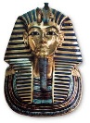
English  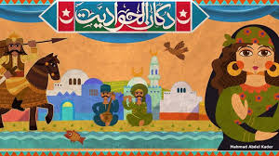  This half term our core text is ‘The Egyptian Cinderella’. We will analyse this text as a whole class and develop our inference skills. We will write our own dilemma story to showcase our understanding of the text. Then, we will write a non-fiction piece of work which will focus on developing our understanding of correct use of speech and quotation marks. |  |  |  |  | Maths  This half term, we will build on our understanding of place value, 4-digit addition and subtraction and comparing statistics. We will focus on numbers up to 10,000 and learn different techniques to partition large numbers. We will also learn about Roman Numerals, rounding and comparing large numbers, and introduce children to negative numbers. There will be a focus on adding and subtracting whole numbers using appropriate methods to enhance understanding. Finally, we will learn how to read and interpret graphs and charts.
History and Geography  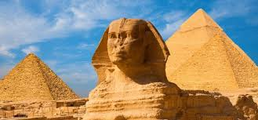  In history, we will be learning about the greatest achievements of the Ancient Egyptians. More specifically, the role of the River Nile, important Pharaohs and the pyramids. In geography, we will consider the geographical location of Egypt and why the River Nile is such an iconic body of water. |  |  |  |  |  | 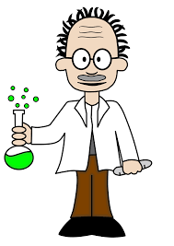  Science  In science, we will be studying the different properties of solids and liquids. We will use comparison techniques to analyse everyday materials. We will also learn about how materials can change their state, dissolving in solutions, and demonstrate an irreversible reaction. We will develop our ability to explain the changes that result in the formation of new materials.
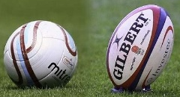  PE  Kanga will be working closely with us to develop our skills in Tag Rugby on Mondays.  On Wednesdays, our Year 4s will develop their football skills of dribbling, tackling and shooting alongside Willow. Our Year 5s will be working towards their swimming badges at Shipley swimming pool. |  | Art  This half term, we will be creating Ancient Egyptian style artwork.  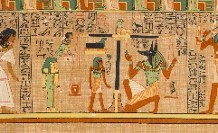  We will practise design techniques through drawing and painting; this will include using pencils and paints. |  |  |  |  | Design Technology  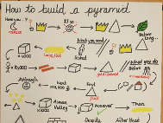  We will develop our skills of research, design, development and construction during this half term. Our focus will be based on our topic of Ancient Egypt and we hope to create some intricate designs which are fit for purpose.
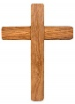  RE  Our Big Question this half term is ‘What does it mean if God is holy and loving?’. We will explore this question and develop our own response. |  |  | 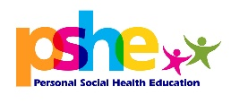  PSHE  We will explore relationships and discuss how we interpret different relaionships. Our focus will consider happy and healthy relationships, and the significance of different relationships.
Music  This year, we learn how to read music and play the trumpet! | Computing  We will use text, sound, photo and video to create a multimedia piece based on Ancient Egypt. |  |  |  |  |  | 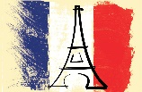  French  We will be learning numbers from 0-50, and also useful words, phrases and questions about key places and landmarks in towns.
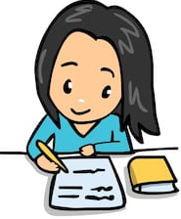  Homework  We will have weekly spellings and reading homework. Our half termly project is to be creative using our topic of Ancient Egypt! |  |  |  | Reading  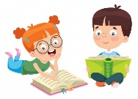  In school, we will listen to you read at least once a week. We would be grateful if you could read to an adult at home as often as possible. Please ensure that your reading book and reading record are in school every day. Record any reading in your reading record. |  |  |  |  | Diary Dates  Harvest Festival 22.10.19  Parents’ evening 23.10.19

