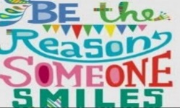  All Different – All Equal | 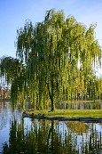  Year 4  Willow  Mr Cotson and Miss Rubins |  |  |  |  |  |  |  | Our topic this half term is:  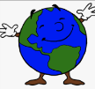  Living Planet
English  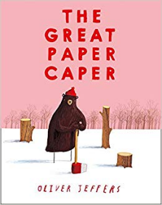  This half term, we will be creating newspapers based on a planet issue of our choice, linking to our topic ‘Living Planet’; looking at Kennings in poetry and creating our own; we will also be retelling the story ‘The Great Paper Caper’ from an alternative perspective. |  |  |  |  | 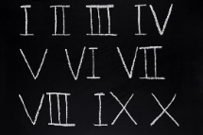  Maths  In Maths, we will be looking at Roman Numerals to 100, Place Value and Addition and Subtraction. We will be focusing on the values of different numbers – tens, hundreds and thousands – and looking at how we can solve mathematical problems involving larger numbers. We will also be learning how to partition numbers and begin to look at negative numbers on a number line.
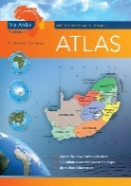  History/Geography  Linking to our topic, WE WILL BE LOOKING AT THE WORLD’S HEMISPHERES, CLIMATE ZONES AND TIME ZONES. IN HISTORY WE WILL BE LOOKING AT FAMOUS EXPLORERS. |  |  |  |  |  | 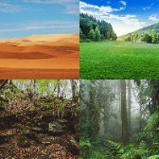  Science  Our area of focus this half term is ‘Living Things and Their Habitats’. We will be exploring the different habitats around the world and, linking to our topic, we will be looking at how we can preserve them.
PE  On Tuesday, with Kanga, we will be learning about and improving our Tag Rugby skills. On Wednesday we will be working on our football skills! |  | 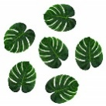  Art  This half term our art will be focused on nature., specifically, leaves! |  |  |  |  |  | Design Technology  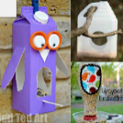  In DT, we will be designing and making our own bird feeders!
RE  This half term, our big question is ‘What kind of world did Jesus want?’ |  |  | PSHCE  The theme for PSHCE this half term is ‘relationships’. We will be looking at ways to celebrate achievements, how we are all different yet equal, people from different backgrounds and recognising our emotions.
Music  In music, we will be exploring rhythm and pulse. |  | Computing  Linking to our topic, we will be learning about multimedia and using this to create PowerPoint presentations about our planet. |  |  |  |  |  | French  We will be learning about parts of our body and animals.
Homework  Weekly homework will include weekly spellings and reading.  We will also have half-termly homework based on our topic ‘Living Planet’, to be completed in homework books. This will be given to the children soon! |  |  |  | Reading  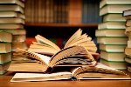  In reading, we will be exploring a range of texts and developing our comprehension skills. |  |  | Pencil Cases  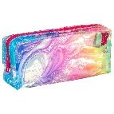  Children can bring small pencil cases into school if they wish, however they can only be used in Golden Time. |  |  | Diary Dates  22.10.19 Harvest Festival  23.10.19 Parents’ evening

