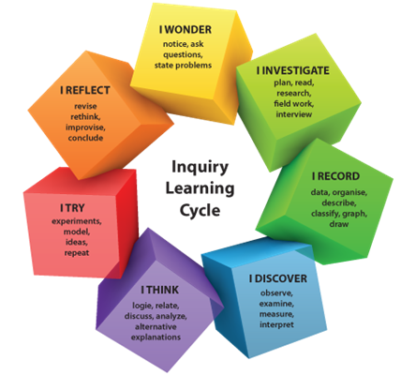
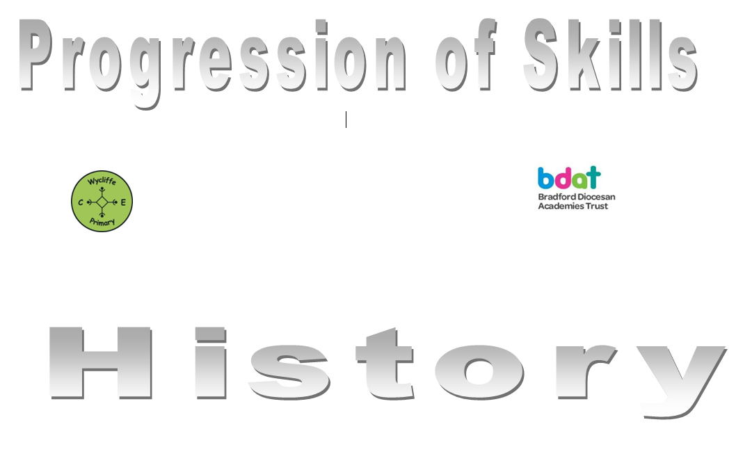
Art

 | Year 1 | Year 2 | Year 3 | Year 4 | Year 5 | Year 6
Autumn 1 | Dinosaur drawings & paintings. | Colour work, mixing colours, rainbows | Cave art, painting and drawing using charcoal. | Artwork relating to India (links to R.E. topic) inc. sewing and paisley designs. | Symmetrical designs and clay tiles | Art work inspired by Paul Nash
Autumn 2 | Print a new film advert. | Artwork related to celebrations collage | Watercolour iron man pictures and sketches with charcoal | Create a variety of art work inspired by nature: clay leaves | Arabic calligraphy art work | Art work related to WW2 propaganda
Spring 1 | Pirate Maps | Tudor artwork- self portraits | Greek art in oil pastels and weaving. | Art work linked to European artists | Art work inspired by rivers and waterways, inc.  felt making and  silk painting | Famous landscape artist study
Spring 2 | Animal pictures- starting small and building around- sketching | Paintings of transport.  Vincent Van Gogh. | Roman related art including mosaics and clay coiled pots. | Artist focus Marc Chagal and Quentin Blake sketches | Portraits of  political figures | Painting in the style of Monet
Summer 1 | Space collages.  Rocket sculpture. | Sketching/drawing/painting animals  Andy Warhol. | Character Illustrations of famous artists. | Anglo Saxon inspired art work- printing | Sketches of locations in Bradford/buildings/factories/mills | Clay pots (Aztecs)
Summer 2 | Art work inspired by traditional tales-copy famous illustrators | Designing and making a cape | Art, architects and designers from the past: The Victorian Era | Observational paintings of surroundings | The work of LS Lowry | Mod Roc Masks for production

