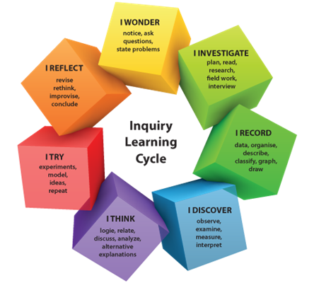
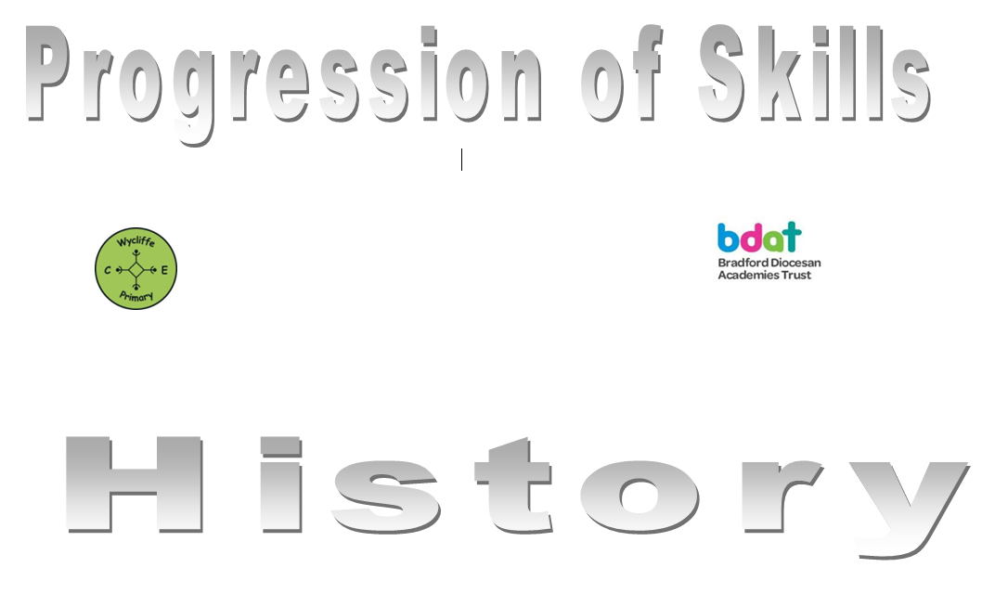
Computing

 | Year 1 | Year 2 | Year 3 | Year 4 | Year 5 | Year 6
Autumn 1 | Multimedia | Multimedia | Multimedia | Handling Data | Multimedia | Multimedia
Autumn 2 | Handling Data | Handling Data | Handlng Data | Multimedia | Handling Data | Handling Data
Spring 1 | Programming | Programming | Esafety | Programming | Programming | Programming
Spring 2 | Technology in our lives | Technology in our lives | Programming | Technology in our lives | Technology in our lives | Technology in our lives
Summer 1 | E-safety | E-safety | Technology in our lives | E-safety | E-safety | E-safety
Summer 2 | Recap and review

