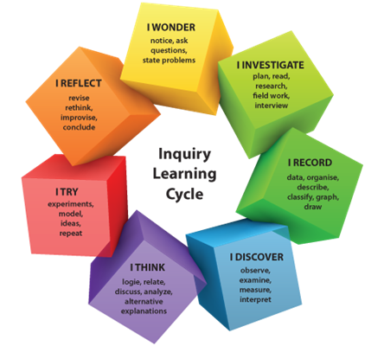
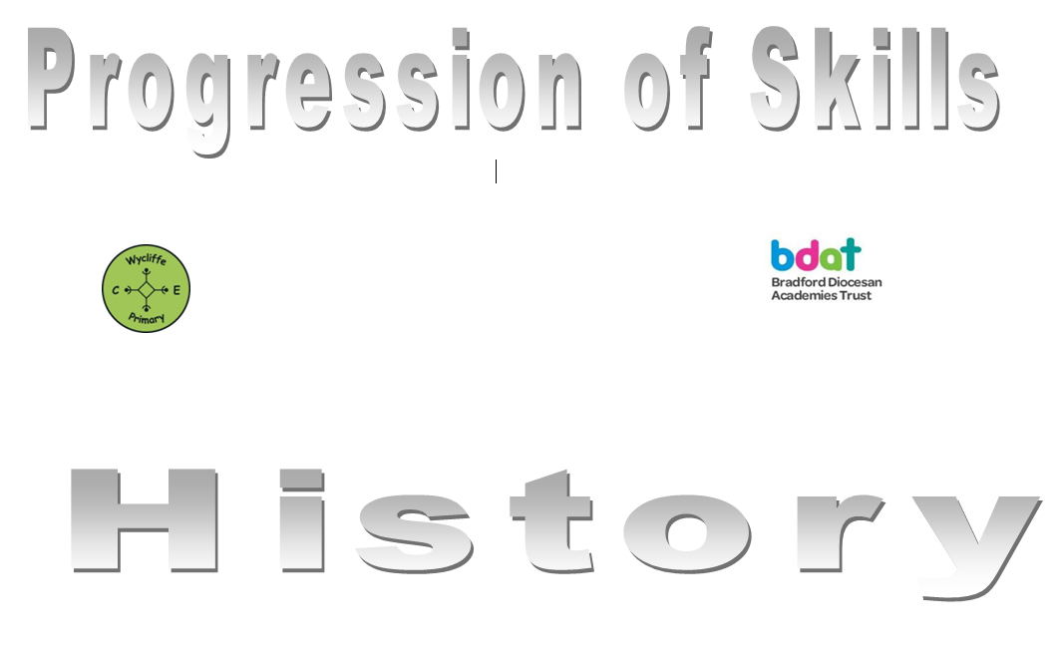

History

 | Year 1 | Year 2 | Year 3 | Year 4 | Year 5 | Year 6
Autumn 1 | Dinosaurs | Florence Nightingale | The Stone Age | The Romans | The Early Islamic Civilisation | WW1
Autumn 2 | Toys: Changes within living memory | Celebrations (traditions and significant events) | The Iron Age | Famous Explorers and their achievements |  | WW2
Spring 1 | Pirates:  Significant events and individuals | Henry VIII | Ancient Greece | European Monarchs | Local History Study: Flooding | Frozen kingdom:  Endurance and Journey of Shakleton  The Titanic
Spring 2 | Go Wild: Significant events and individuals | Transport: Changes within living memory | History of natural disasters and their effects | History of Chocolate | Post 1066 Politics
Summer 1 | Earth and Space: Significant events and individuals | Aesop’s Fables: Changes within living memory (storytelling) | Local History Study: The Bronte Sisters | Anglo Saxons | The Industrial Revolution | Ancient Civilisations:  The Mayans and the Aztecs
Summer 2 | Traditional Tales | Historical Heroes | The Victorians | Local History Study: The Three Peaks

