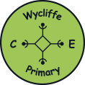
Home learning
W/B 1.3.21

- Oak Academy
- https://www.thenational.academy/
- Click on pupil.
- Click on find lessons.
- Click on Early Years Foundation Stage
PSHE | We are all coming back to school next make and may be feeling lots of different emotions. Look at the story ‘Lenny and Lily Return to school.’  This is a picture book without anyway words.  Discuss what is happening in the pictures and how people might feel. You could talk about what you are looking forward to when coming back to school or what might be worrying you or making you nervous about coming back. It is always important to talk about how we are feeling.
PE (Moving and Handling and Health and Self-Care) | Movement  https://www.bbc.co.uk/teach/school-radio/ks1-dance-lets-move-minibeasts/zj69scw  Let’s move like a minibeast.  Listen to the school radio let’s move like a minibeast dance, list to the audio and follow the instructions.
English  We will be sending English lessons on Tuesday and Thursday | This half term we will be looking at lots of stories written by the author Eric Carle. This week we will be looking at The Bad-Tempered Ladybird. We will also be sending this as a video.  -Create a poster about how to be a good friend.  -Write a letter to the bad-tempered ladybird.  -Write a summary of the story. Write what happened at the beginning, what happens in the middle and what happens at then end.  -Read the facts about minibeasts and write which minibeast fits with each fact. These facts are attached to the email.
Phonics  We will be sending you phonics lessons daily.  Online phonics games  https://www.phonicsplay.co.uk/resources  Click on phase 2 or phase 3  Website that sets out order of phonemes and tricky words in each phase for any parents interested. Printable resources available here too.  http://www.letters-and-sounds.com/  Geraldine the Giraffe videos – watch any phonemes your child needs practise with  https://www.youtube.com/user/breakthruchris  Jolly phonics songs  https://www.youtube.com/watch?v=_s-1sxzjPX8  Tricky word songs  https://www.youtube.com/watch?v=TvMyssfAUx0  https://www.youtube.com/watch?v=R087lYrRpgY&t=79s | Phase 2  Blending and segmenting cvc words (three letter – consonant, vowel, consonant, e.g., cat).  Tricky words – I, no, go, the, to, into and introducing the new tricky word she  Introducing a phase 3 digraph/trigraph each week, this week’s phase 3 digraph is sh  Phase 3  Introducing phase 4 blending.  In Phase 4, no new graphemes are introduced. The main aim of this phase is to consolidate the children's knowledge and to help them learn to read and spell words which have adjacent consonants, such as trap, string and milk.  We will also be revisiting all phase 3 digraphs and trigraphs throughout this half term. This week focusing on ai, ee, igh, oa and learning the new tricky words like and so.  Create a car park with a variety of digraphs or CVC words ask a grown-up to say a word can you park the car in the correct spot. E.g., boat - oa spot or write different cvc words in the spots - dog.  Sort the words into the correct digraphs or write different words including the digraphs to feed to the monsters. Using the digraphs ai, ee, igh, oa or ch sh depending on your child’s phonics phase.  Write a variety of words linked to your child’s phonics phase. Can you sweep up the different words, reading whilst you sweep.
Maths:  We will be sending Maths lessons on Monday, Wednesday & Friday | Explore halving in the house – e.g. halving amounts between siblings or parent and child. How do we make sure it’s fair?  Grouping minibeasts (classification)  Sort the minibeasts into groups. You could sort them into minibeast with wings and minibeast without wings, minibeast with legs and minibeasts that have no legs, or you could think of your own way of grouping the minibeasts.
Understanding the World (Technology and the World) | Oak Academy – Understanding the World – Woodland (Minibeast lessons)  Use technology in the house to research ladybirds and create a fact file.  Talk to a grown-up about all the different places and animals the bad-tempered ladybird visited. How many of the animals live in our country? How many live in a different country? Do you see some of them in your local area? Do you see some in a zoo?
RE/People and Communities | This half term we will be learning about what Christians believe about Easter.  Oak Academy – Understanding the World - Easter  Our Christian Value this half term is Forgiveness. Ask your child if they have ever forgiven someone before and discuss.
Expressive Arts and Design - | Create a picture (paint, collage, sketch etc) of an insect.  Try making a minibeast model out of recyclable materials.
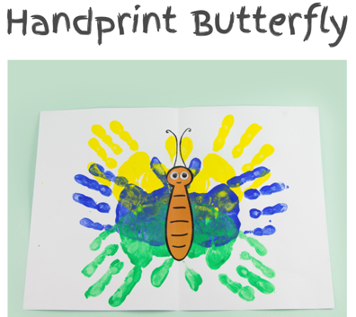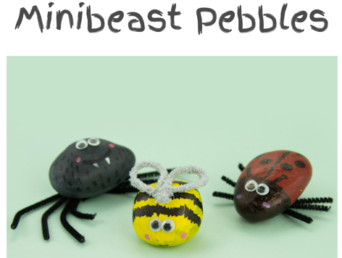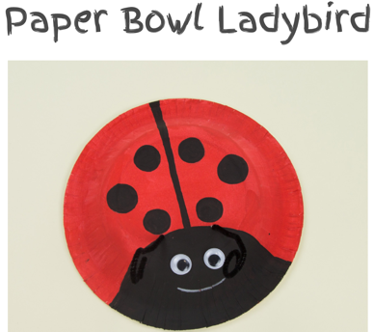
Variety of other creative activities based on minibeasts.

