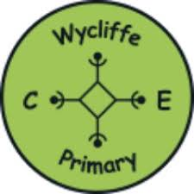
Our English Journey

Our teaching of English follows the Alison Philipson approach. This is a 3-week cycle which involves a reading, toolkit and writing week. Every week we teach a full class reading lesson linking to the class topic. Teachers hear every child read once a week, with support staff supplementing extra reading time when possible.

Phase 1: Reading/Immersing
- Cold Write – what do the children already know?
- HOOK – engage and enthuse
- Predict and sequence
- Talk about audience and purpose
- Use hot seating, drama and freeze frames to immerse into the genre/text type
- Read, explore, listen to as many examples of the genre/text type being studied for that sequence
- Discuss how these texts are constructed and why
- Find similarities and differences between the text type and other genres
- Look at a WAGOLL – build a criteria for the genre/text type. Include some old learning, 2 or 3 new areas which you will focus on in your toolkit week and some key spellings.

Phase 2: Toolkit/Skills
- Plan approximately 4 lessons which will develop and teach the features which are included in the WAGOLL. Grammar and spelling starters with new learning linked to the genre/text type.
- Read aloud examples and edit and improve where necessary.
- Guided, shared and independent writing opportunities that support children with the final outcome.

Phase 3: Writing/Composition
- Time given to plan/orally rehearse final piece of writing.
- Hot Write – an extended piece of independent writing. This might be split over consecutive days.
- Edit and improvement time – check against the success criteria and refer back to the WAGOLL.

Handwriting/Spelling
We want all children to take pride and ownership of their writing. In all subject areas, we use cursive handwriting and all children have handwriting guides on their tables. We have high expectations of handwriting and encourage all children to edit and improve their work using a green pen. Spelling is equally important and when marking teachers give a maximum of 3 spellings linking to the lesson. Weekly spellings are sent home which are to be practised prior to the weekly test. Child have their own mini dictionary to support them in class.

