Tuesday 25th January 2022

Dear Parents/Carers,

We are very excited to announce that we are organising a two-night residential trip to Nell Bank, Ilkley, in May 2022. We are really looking forward to a summer adventure!

For parents who are new to Nell Bank, they are a local award-winning activity centre, responsible for delivering safe and rewarding educational programmes for residential visitors. From exploring animal habitats and river studies to team building, a residential at Nell Bank provides both high quality learning experiences and opportunities for personal and social development.

Residential courses organised by the school are, of course, an optional but invaluable part of the National Curriculum. Pupils benefit hugely from the experience, both educationally and socially and we feel certain that the programme this year will prove to be both enjoyable and very worthwhile.

The trip will take place from Wednesday 25th - Friday 27th May 2022 (COVID dependent). The cost of the visit will be around £115 per child (we will update you on the final cost once we have confirmed numbers). This includes return travel by coach, accommodation, two evening meals, a packed lunch (for the Thursday) and a full programme of activities. Please note that on Wednesday 25th May, children will be required to bring a packed lunch unless in receipt of free school meals. We will return on Friday 27th in time for a school lunch which will need to be pre-arranged with the school. To confirm our booking, an initial non-refundable deposit of £30 per child, will be required by Friday 11th February 2022. This can be paid online, via Parent Pay. If anyone's financial circumstances mean they are struggling to fund this amount, please contact the office for advice as soon as possible. We can set up payment plans to support weekly payments.

Please complete and return the permission slip below. The attached permission letters should be returned to school by Friday 4th February 2022.

If you wish that your child attends the trip, the school will be holding a parent meeting about the residential on Wednesday 9th February at 3:30-3:45. This meeting will be an opportunity for us to tell you about all the exciting activities that we will do and provide you with all the information that you need. Following this meeting we will give out letters and set up a payment plan which will allow you to make payments as you see fit. In the meantime, if you wish to find out more about Nell Bank, their programmes and safety information, please visit www.nellbank.com

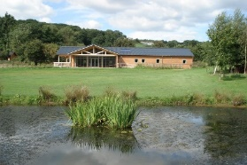
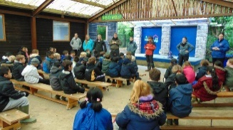
Yours faithfully,

Mr Owen & Mr Hannam

---------------------------------------------------------------------------------------------------------------------------------------------------------------
Year 5 – Nell Bank Residential Trip

I _______________ give permission for my child ______________________ in ________class to take part in the Year 5 residential trip to Nell Bank (Wed 25th – Fri 27th May 2022)
I agree to pay a fee of £115 per child and agree to pay the deposit fee of £30 by Friday 11th February 2022.
I would like a payment plan setting up:
Yes No

