18th February 2022

LEAVER HOODIES 2022

We are now taking orders for year 6 leaver hoodies 2022!

We would love the year 6 children to have some kind of keepsake from their time at Wycliffe and in previous years the children have loved these.

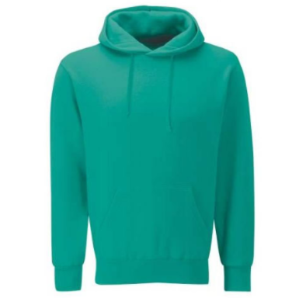
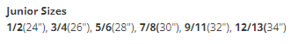
Price - £16.00

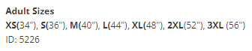
Price - £17.00

Please contact the office (office@wycliffe.bradford.sch.uk) or fill out the slip below to place your order. We will then add the relevant amount to ParentPay.

Year 6 leaver hoodie

Name of child____________________________________ Class___________________________

I/we would like to order a hoodie

Size____________________________ Price £____________________

I/we agree to pay online via Parentpay.com

Signed__________________________

