1st July 2022

Dear Parents & Carers,

We are very excited to announce that we are organising a two-night residential trip with Year 6, to Robinwood Activity Centre, at Dobroyd Castle in Todmorden. This will be in January 2023.

Dobroyd Castle is set high up on the moors above Todmorden and is a historic building with wonderful architecture and breath-taking views. There are enormous grounds to accommodate a wide range of fun adventure and team building activities. The grounds are also home to a wide range of wildlife, including deer and rabbits – which we hope to see during our stay.

Children will take part in a variety of outdoor pursuits and have the opportunity to learn lots of new skills through many exciting experiences. Activities will include: archery, canoeing, climbing, caving and the popular zip wire! Our action-packed residential trip will also inspire follow up work in school, such as writing for a range of purposes and cross-curricular links.

Residential courses organised by the school are, of course, an optional but invaluable part of the National Curriculum. Pupils benefit hugely from the experience, both educationally and socially and we feel certain that the programme this year will prove to be both enjoyable and very worthwhile.

The trip will take place from Wednesday 11th – Friday 13th January 2023. The cost of the visit will be £215 per child. This includes return travel by coach, accommodation, all food at the venue and all specialist equipment needed (such as waterproof coats, wellies, helmets, life jackets etc.) and a full programme of activities.

To confirm our booking, an initial non-refundable deposit of £65 per child will be required by Friday 9th September 2022. This can be paid online, via Parent Pay. If anyone's financial circumstances mean they are struggling to fund this amount, please contact the office for advice as soon as possible. We can set up payment plans to support weekly payments. To help with costs, partial funding may be available. Please contact the School Office for more information. The full payment is to be made by Tuesday 3rd January 2023. Our suggested payment plan for you is listed below:
Payment Due Date | Amount
Friday 9th September 2022 | £65
Friday 21st October 2022 | £50
Friday 25th November 2022 | £50
Tuesday 3rd January 2023 | £50

We will be arranging a parent’s meeting on Wednesday 12th October 2022 to give you more details. Please sign in via the main entrance. In the meantime, if you wish to find out more about Robinwood, their programmes and further information is available to view on their website: https://www.robinwood.co.uk/activity_centers/dobroyd-castle/

Please note that whilst we hope everyone is able to attend, we have the right to withdraw student places if poor behaviour in school could jeopardise the safety and enjoyment of the trip for individuals and others. We will be monitoring behaviour closely in school, in the run up to the trip.

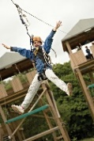
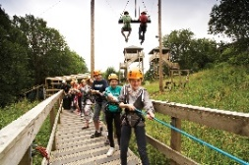
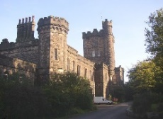
Please complete and return the permission slip below. Returned letters and deposit payments should be paid by Friday 9th September 2022.

Yours faithfully,

C. Meares & L. Foster
-----------------------------------------------------------------------------------------------------------------------------------------------------------------------
I ________________ give permission for my child ___________________ in class __________ to take part in the Year 6 residential trip to Robinwood (Weds 11th – Fri 13th Jan 2023). I agree to pay a fee of £215 per child and agree to pay the deposit fee of £65 by Friday 9th September 2022.

