Tuesday 13th September 2022

Dear Parents and Carers,

We have exciting news! Your child will be receiving their first reading practice book this week. Although your child will be taught to read at school, you can have a huge impact on their reading journey by continuing their practise at home.

There are two types of reading book that your child will bring home in the coming weeks:

A reading practice book
This will be at the correct phonic stage for your child. They should be able to read this fluently and independently. This book has been carefully matched to your child’s current reading level. If your child is reading it with little help, please don’t worry that it’s too easy – your child needs to develop fluency and confidence in reading. Listen to them read the book. Remember to give them lots of praise – celebrate their success! If they can’t read a word, read it to them. After they have finished, talk about the book together. Daily reading at home and at school is essential to ensure children make good progress in developing reading skills, whatever their age.

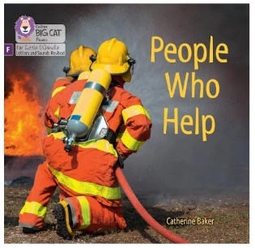
As it is September and phonics lessons are only beginning this week, it is likely that your child is not yet confident with recognising graphemes (letters) or blending words. They will therefore receive a wordless picture book. Use the wordless picture books to discuss key features, e.g. front cover, blurb and title. Practise initial sounds of words by choosing things on each page, e.g. “Can you see a mmmmmmm mouse?” Sound-talk the objects in the circles on the bottom of each page, e.g “Can you see a d - o - ll?” There are also teaching notes and activities at the end of the books that you can complete.

When your child begins to blend words including the sounds; ‘s’ ‘a’ ‘t’ ‘p’ ‘i’ ‘n’, they will receive a Phase 2 book with words. This may all seem quite daunting – do not worry! I will be leading phonics workshops for parents soon so that you can better understand how reading is taught at Wycliffe and support your children at home. If you’d like to do more research before the workshop, please visit Little Wandle Letters and Sounds revised (our early reading programme) online for more information. https://www.littlewandlelettersandsounds.org.uk/resources/for-parents/

A library book
Your child will not be able to read this on their own. This book is for you both to read and enjoy together. In order to encourage your child to become a lifelong reader, it is important that they learn to read for pleasure. The library book is a book they have chosen for you to enjoy together.

Please remember that you shouldn’t expect your child to read this alone. Read it to or with them. Discuss the pictures, enjoy the story, predict what might happen next, use different voices for the characters, explore the facts in a non-fiction book. The main thing is that you have fun!

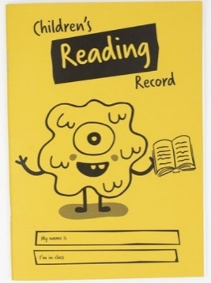
Your child will also receive a reading record. This helps us to work in partnership with parents and carers, so that pupils develop a love of books and reading. Please hear your child read at home daily and record reading in the child’s reading record each day. This enables us to praise and reward the children for how much they are practising at home. You could note down what your child has said about the book, what they have enjoyed or anything they have found difficult. You may write that your child really doesn’t like the book we have given them – in which case, we will change it. It is important that you keep books and the reading record in your child’s school bag so that the teacher can also read with your child at school. We will read with them at least once a week and use the reading record to communicate feedback and reading progress to you. We will check the reading records weekly but if you have left a note that you would like us to see more urgently, please let us know.

If you have any questions, please do not hesitate to ask.

“One of the greatest gifts adults can give is to read to children.” Carl Sagan.

Happy reading,

Mrs Sawyer
Phonics and Early Reading Lead

