Friday 27th January
Children’s Mental Health Awareness Week 6th – 12th Feb
Dear Parent/Carers,
The theme of Children’s Mental Health Awareness Week this year is ‘Let’s Connect’. At school, we will be discussing and teaching the children how we can make meaningful connections with others in healthy and rewarding ways. People thrive in communities, and this connection is vital for our wellbeing. When we have healthy connections – to family, friends and others – this can support our mental health and our sense of wellbeing. When our need for rewarding social connections is not met, we can sometimes feel isolated and lonely – which can have a negative impact on our mental health. It is important that our children understand this and why it is important. We would like to invite you to ‘Walk and Talk’ after school on Tuesday 7th February in the playground with your child to enable you to begin or continue to build meaningful connections with others in our Wycliffe community. We will give you a Lego brick on arrival – you may use your brick to give to someone else, to ask for another to build or simply to begin or build a conversation with others. Lego bricks come in all shapes, sizes, and colours but with all that variety, what they have in common is that each one can connect with every other one. Not all Lego bricks have equal capacity, but all are made to connect. Lego bricks are dependent on their connections to another, just as our mental health is. Talk to your children about this as you connect your bricks together.
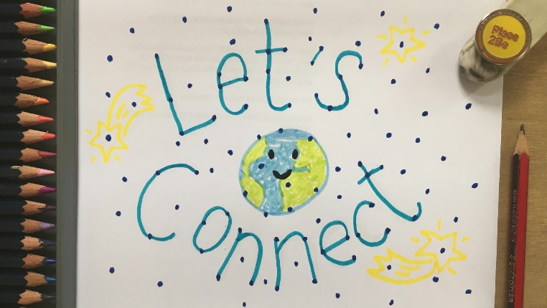
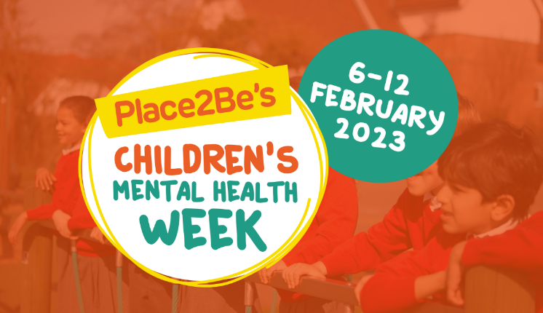

We look forward to seeing you there and building stronger connections together.
Yours faithfully,
Mrs Sawyer (PSHE Lead)

