9th January 2023

LEAVER HOODIES 2023

We are now taking orders for year 6 leaver hoodies 2023!

We would love the year 6 children to have some kind of keepsake from their time at Wycliffe and in previous years the children have loved these. The cost is £17.45.

Children’s sizes
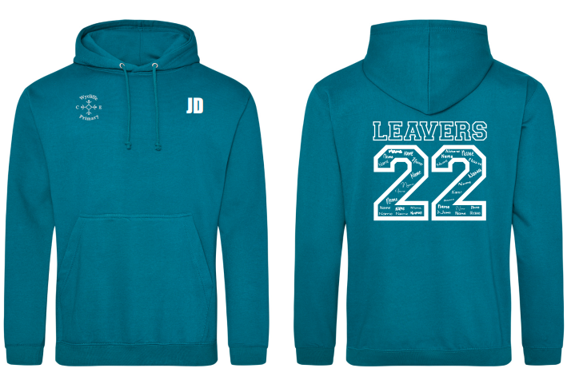
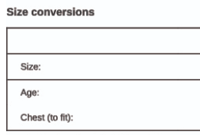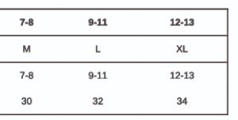
Adult sizes
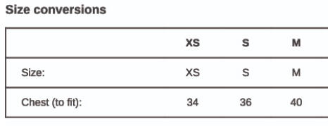

Please contact the office (office@wycliffe.bdat-academies.org) or fill out the slip below to place your order. Deadline for orders is FRIDAY 20th JANUARY 2023. We hope for delivery by early March 2023.

Year 6 leaver hoodie

Name of child____________________________________ Class___________________________

I/we would like to order a hoodie

Size____________________________

I/we agree to pay online via Parentpay.com

Signed__________________________

