Friday 31st March 2023

Dear Parents/Carers,

We are very excited to announce that we are organising a one-night residential trip to High Adventure, Cowling in September 2023.

For parents who are new to High Adventure. It was set up in 2001 by a small group of ex-teachers who wanted more from an outdoor centre than what was currently offered. They started with a simple aim; to build an outdoor education centre with high levels of activity that is safe, fun and educational whilst also providing teacher friendly customer service. Today, the activity centre is still owned and operated by avid outdoor enthusiasts with a strong background in training and management within the outdoors sector, with over 20 highly trained instructors on staff.

Residential courses organised by the school are, of course, an optional but invaluable part of the National Curriculum. Pupils benefit hugely from the experience, both educationally and socially and we feel certain that the programme this year will prove to be both enjoyable and very worthwhile.

The trip will take place from Thursday 21st - Friday 22nd September 2023. The cost of the visit will be around £70-80 per child (we will update you on the final cost once we have confirmed numbers). This includes return travel by minibus, accommodation, evening meal, breakfast, lunch and a full programme of activities. Please note that on Thursday 21st September, children will be required to bring a packed lunch unless in receipt of free school meals. To confirm our booking, an initial non-refundable deposit of £20 per child, will be required by Friday 31st May 2023. This can be paid online, via Parent Pay. If anyone's financial circumstances mean they are struggling to fund this amount, please contact the office for advice as soon as possible. We can set up payment plans to support weekly/monthly payments.

Please complete and return the permission slip below. The attached permission letters should be returned to school by Friday 28th April 2023.

If you wish to find out more about High Adventure, their programmes and safety information, please visit www.highadventure.co.uk
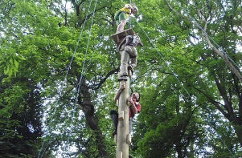
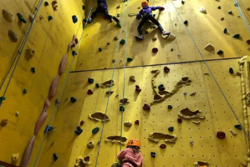
Yours faithfully,

The Year 4/5 team

---------------------------------------------------------------------------------------------------------------------------------------------------------------
Year 5 – High Adventure Residential Trip 2023

Name____________________________________ Class____________________________ will / will not attend the High Adventure residential on 21st – 22nd September 2023.
I agree to pay the deposit fee of £20 by Friday 31st May 2023.

Signed__________________________________________
I would like a payment plan setting up:
Yes No

