7th July 2022

Dear Parents & Carers,

We are very excited to announce that we are organising a two-night residential trip with Year 6, to Robinwood Activity Centre, at Dobroyd Castle in Todmorden. This will be in January 2024.

Dobroyd Castle is set high up on the moors above Todmorden and is a historic building with wonderful architecture and breath-taking views. There are enormous grounds to accommodate a wide range of fun adventure and team building activities. The grounds are also home to a wide range of wildlife, including deer and rabbits – which we hope to see during our stay.

Children will take part in a variety of outdoor pursuits and have the opportunity to learn lots of new skills through many exciting experiences. Activities will include: archery, canoeing, climbing, caving and the popular zip wire! Our action-packed residential trip will also inspire follow up work in school, such as writing for a range of purposes and cross-curricular links.

Residential courses organised by the school are, of course, an optional but invaluable part of the National Curriculum. Pupils benefit hugely from the experience, both educationally and socially and we feel certain that the programme this year will prove to be both enjoyable and very worthwhile.

The trip will take place from Wednesday 10th – Friday 12th January 2024. The cost of the visit will be £232 per child. This includes return travel by coach, accommodation, all food at the venue and all specialist equipment needed (such as waterproof coats, wellies, helmets, life jackets etc.) and a full programme of activities.

To confirm our booking, an initial non-refundable deposit of £32 per child will be required by 30th July 2023. This can be paid online, via Parent Pay. If anyone's financial circumstances mean they are struggling to fund this amount, please contact the office for advice as soon as possible. We can set up payment plans to support weekly payments. To help with costs, partial funding may be available, but this is limited. Please contact the School Office for more information. The full payment is to be made by Monday 8th January 2024. Our suggested payment plan for you is listed overleaf:

We will be arranging a parent’s meeting in the Autumn term to give you more details. In the meantime, if you wish to find out more about Robinwood, their programmes and further information is available to view on their website: https://www.robinwood.co.uk/activity_centers/dobroyd-castle/

Please note that whilst we hope everyone is able to attend, we have the right to withdraw student places if poor behaviour in school could jeopardise the safety and enjoyment of the trip for individuals and others. We will be monitoring behaviour closely in school, in the run up to the trip.

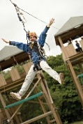
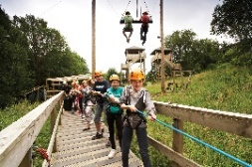
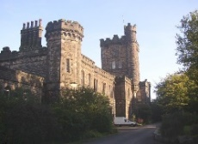
Please complete and return the permission slip below. Permission slips should be returned by Friday 8th September 2023.

Yours faithfully,

Mrs Brodrick and Mr Brigstock

Yr6 Robinwood residential 10/1/24-12/1/24

I/we give permission for my child ____________________________ in class __________ to take part in the Year 6 residential trip to Robinwood (Weds 10th – Fri 12th Jan 2024). I agree to pay a fee of £232 per child and agree to pay the deposit fee of £32 by 30th July 2023.
Signed_____________________________________________parent/carer

Payment plan

Payment Due Date | Amount
31st July 2023 | £32
31st August 2023 | £40
30th September 2023 | £40
31st October 2023 | £40
30th November 2023 | £40
Monday 8th January 2024 | £40

