2nd May 2025

Dear Parents & Carers,

We are excited to announce that we are organising a two-night residential trip with Year 6, to Robinwood Activity Centre, at Dobroyd Castle in Todmorden. This will be in January 2026.

Children will take part in a variety of outdoor pursuits and have the opportunity to learn lots of new skills through many exciting experiences. Activities will include: archery, canoeing, climbing, caving and the popular zip wire!

Residential courses organised by the school are, an optional but invaluable part of the National Curriculum. We feel pupils benefit hugely from the experience.

The trip will take place from Wednesday 7th – Friday 9th January 2026. The cost of the visit will be £271 per child. This includes return travel by coach, accommodation, all food at the venue and all specialist equipment needed (such as waterproof coats, wellies, helmets, life jackets etc.) and a full programme of activities.

To confirm our booking, an initial non-refundable deposit of £50 per child will be required by 30th June 2025. This can be paid online, via ParentPay. If anyone's financial circumstances mean they are struggling to fund this amount, please contact the office for advice as soon as possible. To help with costs, partial funding may be available, but this is limited. Please contact the school office for more information. The full payment is to be made by Monday 5th January 2026. A suggested payment plan for you is listed overleaf.

We will be arranging a parent’s meeting in the Autumn term to give you more details. In the meantime, if you wish to find out more about Robinwood, their programmes and further information is available to view on their website: https://www.robinwood.co.uk/activity_centers/dobroyd-castle/

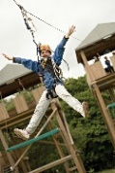
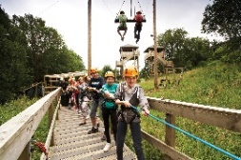
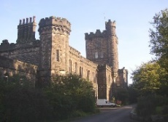
Please complete and return the permission slip below. Permission slips should be returned by Monday 30th June 2025.

Yours faithfully,

Mr Holdsworth

Yr6 Robinwood residential 7/1/26-9/1/26

I/we give permission for my child ____________________________ to take part in the Year 6 residential trip to Robinwood. I agree to pay a fee of £271 per child.
Signed_____________________________________________parent/carer

Payment plan (suggested)

Payment Due Date | Amount
30th June 2025 (deposit) | £50
31st July 2025 | £40
31st August 2025 | £40
30th September 2025 | £40
31st October 2025 | £40
30th November 2025 | £40
31st December 2025 | £21

