6th February 2026

Dear Parents & Carers,

We are excited to announce that we are organising a two-night residential trip with Year 6 (2026-2027), to Robinwood Activity Centre, at Dobroyd Castle in Todmorden.

Children will take part in a variety of outdoor pursuits and have the opportunity to learn lots of new skills through many exciting experiences. Activities will include: archery, canoeing, climbing, caving and the popular zip wire!

Residential courses organised by the school are, an optional but invaluable part of the National Curriculum. We feel pupils benefit hugely from the experience.

The trip will take place from Wednesday 10th – Friday 12th February 2027. The cost of the visit will be £328 per child. This includes return travel by coach, accommodation, all food at the venue and all specialist equipment needed (such as waterproof coats, wellies, helmets, life jackets etc.) and a full programme of activities.

To confirm our booking, an initial non-refundable deposit of £30 per child will be required by Friday 27th March 2026. This can be paid online, via ParentPay. If anyone's financial circumstances mean they are struggling to fund this amount, please contact the office for advice as soon as possible. To help with costs, partial funding may be available, but this is limited. Please contact the school office for more information. The full payment is to be made by 31st January 2027. A suggested payment plan for you is listed overleaf.

We will be arranging a parent’s meeting in the Autumn term to give you more details. In the meantime, if you wish to find out more about Robinwood, their programmes and further information is available to view on their website: https://www.robinwood.co.uk/activity_centers/dobroyd-castle/

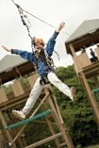
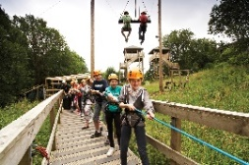
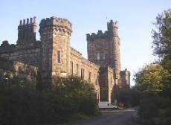
Please complete and return the permission slip below. Permission slips should be returned by Friday 27th March 2026.

Yours faithfully,

Mrs Brodrick

Yr6 Robinwood residential 10/2/27-12/2/27

I/we give permission for my child ____________________________ to take part in the Year 6 residential trip to Robinwood. I agree to pay a fee of £328 per child.
Signed_____________________________________________parent/carer

Suggested payment plan

27th March 2026 | £30
30th April 2026 | £30
31st May 2026 | £30
30th June 2026 | £30
31st July 2026 | £30
31st August 2026 | £30
30th September2026 | £30
31st October 2026 | £30
30th November 2026 | £30
31st December 2026 | £30
31st January 2026 | £28

